Odor Control with Plant Based Micronutrients!
By Derk Maat

Offensive Odors generated by landfills, wastewater plants, transfer stations, food waste receptacles, garbage trucks, yard waste and food waste composting operations(both industrial and consumer back yard composters) sewer systems, pumping stations all have been and are a challenge in urban environments as our cities continue to grow in density.
Stormwater ponds, combined sewer overflow facilities and canals are also many times a source of odors.
Agricultural operations including beef/dairy/hog and poultry prow and processing operations often bordering urban populations also generate odors that are impacting small towns, rural residents and larger urban areas.
Source separation of garbage into separate containers for food waste/ plastic/paper/ refuse etc for pickup works to an extent for single family home owners but is a significant challenge for condo and apartment dwellers as food waste bins are an identified source of odor in every single/multifamily dwelling.
Measurement of offensive fugitive odors has grown into a significant business component in the environmental sector spawning new innovative technology to address the problem. Drone based sampling devices have now been developed to measure odors above and around industrial facilities.
There has been significant progress in measuring and quantifying and source identification of odors generating nuisance complaints from the public to the regulatory agencies.
Landfills and Wastewater Treatment Plants pose many odor challenges
Regulatory agencies are now able to identify facilities and plants responsible for odor generation and force these facilities to deal with odor related problems.
Property values of residential and commercial development are often impacted by the potential/existing/perceived odors coming from neighbouring plants and facilities.
There is a significant incentive now to measure and mitigate fugitive offensive odors.
As a result of economic pressures and technological developments in measuring and quantifying odors mitigation of offensive fugitive odors has also become a significant business component of the environmental sector spawning new technological developments.
Management of odors is a challenge for all systems/plants dealing with organic waste streams.
Current Odor Control Technology
To date most of the new technology being developed is based on chemical breakdown of odors using UV, carbon, Ozone and biological filtration of odors.
Other solutions include oxygenating and aerating solid and liquid waste collection basins to prevent septic conditions- an energy intensive practice.
The least effective method is the use of chemical masking agents – which are often toxic and have human exposure restrictions.
Other initiatives and solutions have been based on the use of biocides to kill bacterial populations that are responsible for the generation of odors. Unfortunately the biocides also kill the non odor producing beneficial anaerobic/aerobic bacteria that are responsible for the biological breakdown of waste material and when used will inhibit the biological processing the liquid and solid organic waste streams. Biocides currently in use consist of chlorine/quartenary ammonia, copper sulphate, and formaldehyde solutions which are highly toxic to the preferred beneficial bacteria and to the environment as these compounds end up being discharged in receiving surface water streams and water bodies continuing their toxic impact on the environment.
These chemicals when used as biocides not only kill the offensive bacteria generating the odor but also kill the bacteria responsible for treating the waste in composting or wastewater treatment operations. It is known that formaldehyde, a known carcinogen and a biocide used to kill odors, and the natural waste degrading bacteria in portable toilets have upset and severely inhibited the biological populations in both small and large wastewater treatment plants thus adversely affecting plant performance and effluent quality being discharged to the environment. Recovery times for these wastewater plants to rebuild their bacterial populations have extended from days to weeks.
Selective biological inhibition of odor producing bacteria
Few if any of these solutions are focused on selectively stopping the generation of odors at the source ie treating the solid/liquid waste streams at source to mitigate the generation of odors by inhibiting odor producing bacteria using selective microorganism stimulants.
Anaerobic sulphur reducing bacteria have been identified as the main source of offensive odorous compounds in organic processes and organic waste treatment systems. These bacteria are active and thrive in the absence of oxygen.
Several selective approaches such as aerating solid/liquid waste streams to biologically inhibit the activity of the odor producing bacteria are costly, energy intensive and tend to produce large quantities of new biological organic biomass which in turn must be treated and disposed of. This approach is only a partial solution as fugitive emissions still require some sort of treatment to generate odor free discharges to the atmosphere.
Little work has been done until recently to limit the activity of these bacteria and thereby eliminate the generation of odors by these organisms present in liquid and solid organic waste streams.
A new biological environmentally sustainable approach using plant based organic micronutrients has been developed over the last number of years to specifically stimulate aerobes and anaerobes and competitively inhibit the sulphur reducing and ammonia forming bacteria and enzymes.
The main active ingredients in the micronutrient solutions include plant sourced amino acids, vitamins and other plant based organic constituents and trace minerals. The micronutrient solution itself is biodegradable as it used up by the beneficial bacteria as food source in found in organic waste streams.
These micronutrients when added to liquid and solid organic waste streams eliminate the formation of odors at the source in the biological reactions that are responsible for organic waste degradation.
The biological reactions at work, when certain micronutrients are added, impact the metabolic rate of certain microbial organisms. Research has shown that non sulphur reducing anaerobes and many different types of aerobes are stimulated by the plant based organic micronutrient catalyst to operate at much higher metabolic rates. Sulphur reducing anaerobes and ammonia generating enzymes are unable to utilize the specific micronutrients introduced into organic waste streams.
As a result, the microorganisms stimulated by the micronutrient solution out compete the odor producing microbes for macronutrients and thereby, by means of competitive inhibition, severely restrict the odor producing microbes in their metabolic activity resulting in a dramatic decrease in the production of odorous gases.
The net impact is that odors are significantly reduced but bacterial breakdown of the organic waste continues at an accelerated rate.
Benefits of biological inhibition of odor producing bacteria
This phenomenon has been observed to take place in sewer systems, wastewater plants, septic tanks, lagoons, composting facilities, stormwater retention ponds or combined sewer overflow ponds where the micronutrient solutions have been added. If micronutrient control of odor generation is implemented there is no need to revert to aerating septic systems, tanks, lagoons or ponds, or treatment facilities to control and/or treat odors.
The advantage with biological source control of odors with micronutrients include:
- Elimination of need for significant infrastructure and space requirements to contain, control and treat odors
- Elimination of 90% of capital investment associated with odor control using chemical and or biofilter infrastructure.
- Elimination of 90% of the energy demand associated with conventional odor control strategies and technologies with a significant associated carbon footprint reduction.
The use of plant based organic micronutrient represents a near zero carbon footprint solution to eliminate odors from most if not all facilities faced with odor control and odor mitigation strategies.
There is an immediate return on the investment for micronutrient usage as it replaces or eliminates the costly operation of biofilters, ozonation units, and carbon units.
Treatment of air borne odorous compounds using micronutrients
Plant based organic micronutrients can also be utilized in misting systems to treat odorous gases generated by nonpoint sources of odors in facility operations like transfer stations, landfills, garbage rooms in commercial facilities, wastewater plants, biosolids processing facilities, and organic material processing facilities like food production plants and/or pulp and paper mills.
These micronutrients can also be used to improve capacity and performance of biofilters and wetscrubbers.
The plant based micronutrients when diluted in ratios varying from 100-1000:1 react with airborne odor molecules in chemical oxidation reactions to render the odorous molecules odor free. The exact mechanism is not fully understood except that when used in this type of application the results in most cases justify the use and cost of the organic plant based micronutrient solutions as most offsite odor complaints are eliminated and working environments on site for staff improve dramatically.
The micronutrient solutions contain no masking agents except in some cases where a tracer fragrance is required.
The micronutrient solutions also do not contain any bacteria or enzymes that may be subject to regulatory restrictions. They also do not contain any minerals in concentrations harmful to the environment.
Inhibition of the production of odorous compounds in waste stream inoculated with micronutrients
The micronutrient solutions when added to the waste streams inhibit the formation of;
- Hydrogen sulphide
- Ammonia
- Trimethylamine
- Methylmercaptans
- And other non-identified sulphur reduced organic compounds
We have carried out a controlled laboratory study to measure the effectiveness of these micronutrient products when added to decaying organic waste. Two reactors with an enclosed head space – a control and test reactor were set up containing 1 kg each of decaying food waste. The test reactor was treated with a one time 5 ml dose of a micronutrient solution identified as Biologic SRC. The reactors were equipped with sampling ports to sample headspace gases and were incubated at a temperature of 30 degrees C to represent warm weather conditions. The reactors were sampled every 12 hours over a five day period. The air bag samples were sent to a certified laboratory and analysed by a GC MS for the four compounds listed above. The reactors were also subjected to a simple olfactory test by the technician.
The control sample was characterized by a highly putrefied odor. The treated sample was free of any objectionable odors. The analytical results are presented as follows.

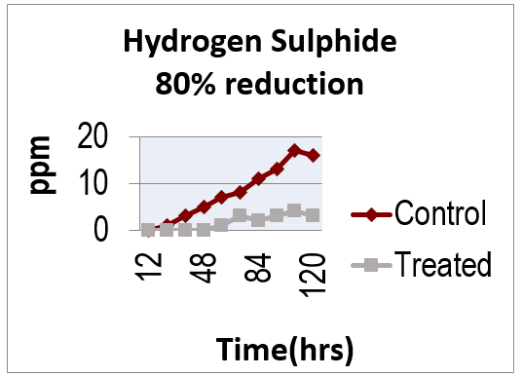

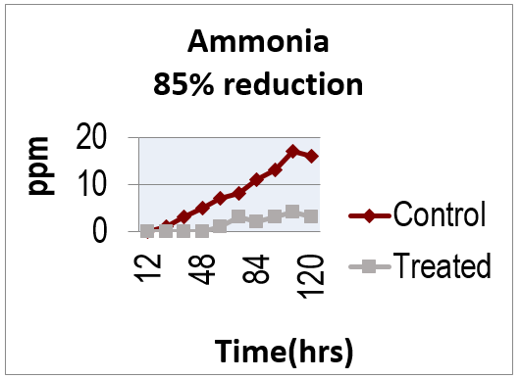
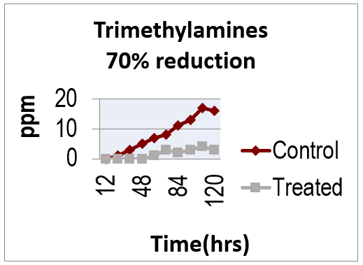

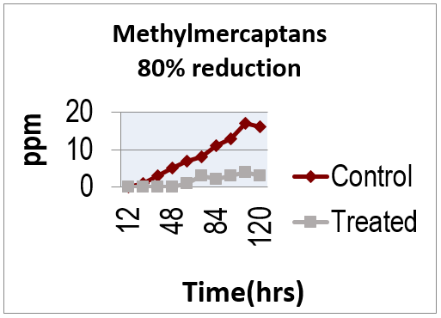

The laboratory tests confirmed that a one-time dose was effective over a 5 day time period to suppress the generation of odorous gases by 70-85% from organic waste incubated at a temperature of 30ºC.
These results have significant implications for the source mitigation of odors from green bins and composters to transfer stations and landfills and wastewater treatment facilities. Further testing has confirmed that solid organic waste degradation rates were increased by up to 65% under laboratory and field conditions.
Misting/Spraying Applications
As earlier discussed, the micronutrient solutions have also been applied in misting applications to oxidize and neutralize airborne non-point source odorous compounds. Air misting in a hog slaughter house barn and in hog rearing facilities resulted in 85-90% reduction in H2S/Ammonia concentrations in the atmosphere. Air misting in poultry barns have shown similar results. Commercial misting applications in garbage rooms of stores, institutions achieved similar reductions.
Misting applications in MSW transfer stations, landfill sites, tipping floor and pits in a MSW incineration plant, chicken rendering plants have all resulted in dramatic odor reduction and elimination of neighbouring odor complaints.
Misting into biofilters improves the performance of biofilms and also complexes odour molecules into non odour generating compounds.

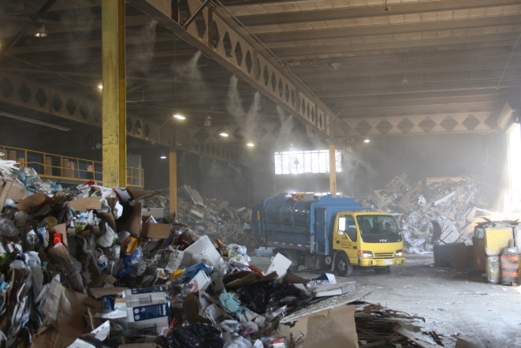
Air misting system in a Transfer Station

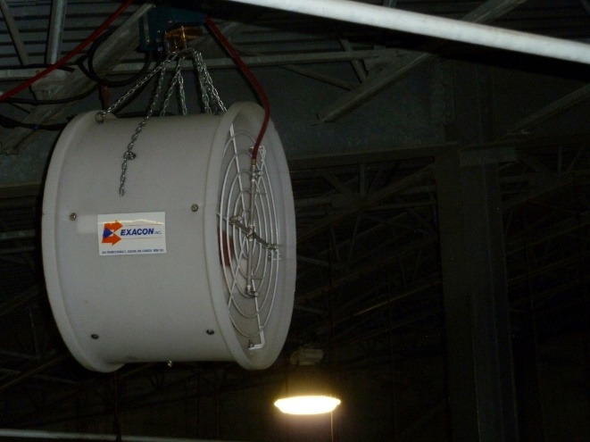
Air misting system in a Chicken Rendering Plant

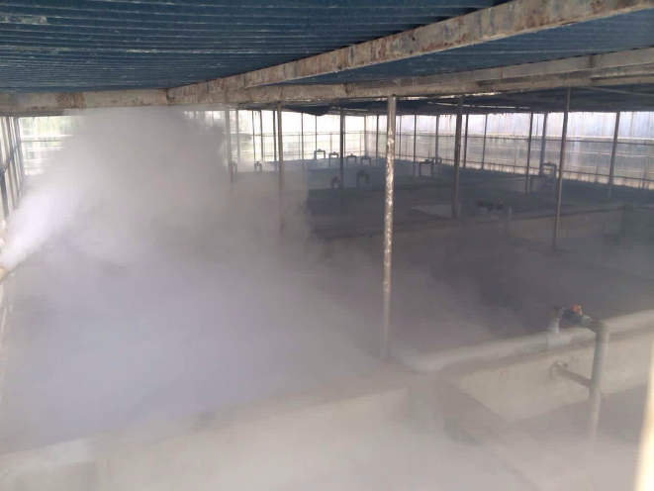
Misting system in a Chicken Rendering Plant

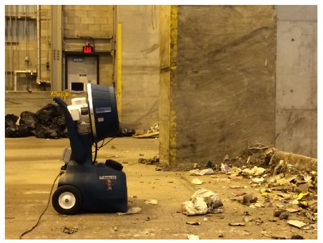
Misting system in an MSW receiving area

Landfill Perimeter Misting System for Odor Control

Industrial misting applications of the micronutrient solutions in tannery facilities and sludge processing facilities also resulted in significant odor reductions. The use of the micronutrient solution in misting applications requires minimal capital investment for infrastructure and has proven to be an effective environmentally sustainable lifecycle cost solution.

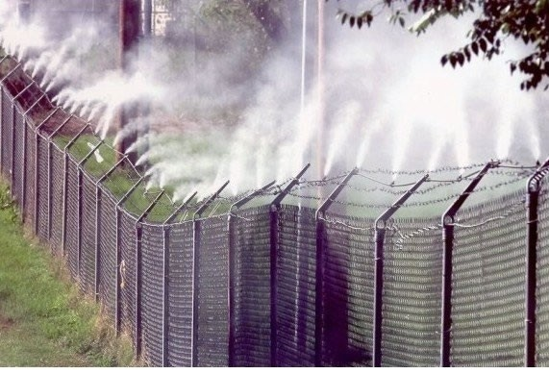

Wastewater treatment plant applications
When applied in wastewater plants for odor control, the micronutrient were at the same time able to improve wastewater treatment performance resulting in reduced operating costs. The typical addition rates for odor control in wastewater plants range from 1 (domestic wastewater) to 10 (industrial wastewater) ppm
Application to biosolids processing plants at 50ppm to 2% TSS sludge mixtures also reduced odors by 80%.
Application in wastewater treatment plant influents by direct injection have also resulted in dramatic reduction in ambient air H₂S reductions as illustrated in the following graph:
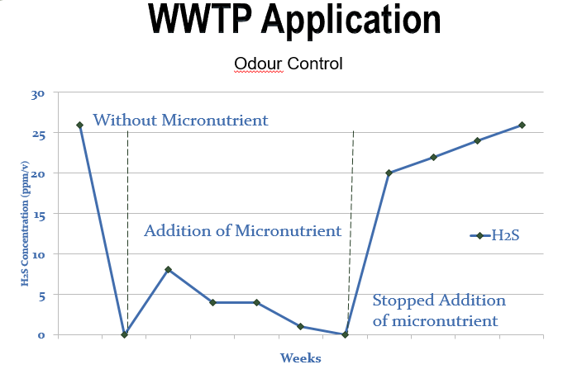
The reduction in the H₂S levels at the plant eliminated all neighbouring offsite odor complaints.
Lagoon and combined sewer overflow pond surface spray applications have eliminated odor generation and odor complaints from lagoons containing effluent from ethanol plants, paper mills, septic tank sludges, hog manure to cherry processing facilities ranging in volume from 500m³ to 45,000m³.
Innoculation of 2% solids sludges from paper mills and wastewater plants prior to dewatering has reduced odors 80-90% and eliminated the need for large biofilters, scrubbers and contaminated air treatment facilities by reducing and/or eliminating the generation of odors at source.
In conclusion, the use of micronutrient solutions for odor source control and odor abatement and stimulation of beneficial biodegradation mechanisms represents an alternative innovative but proven environmentally sustainable approach.
Plant Based Micronutrient Environmental Certifications
The plant based micronutrient products utilized in the applications cited in this article are manufactured and sold by Scicorp International Corp under the BIOLOGIC SRC/SRC3 brand. BIOLOGIC SRC products have been tested and certified non-toxic by a leading toxicity laboratory (TOX Monitor/BSR, Inc. Illinois USA). The product is also certified within the Ecologo/UL program, North America’s largest most respected environmental standard and certification mark. The product has been recently branded by a waste management company and is being marketed as an odor control product for controlling odors from Green Bin food waste containers used by householders in the consumer market in North America.
Derk Z. Maat, M.Eng.,P.Eng., is the CEO of Maat Environmental Engineering. Email derk@maatenv.com

